Term I Math Exam Review
Pages from Notebook:
﻿Page 3 - Review of Perfect Squares/Square Roots﻿
﻿Page 4 - Perfect Squares of Fractions and Decimals
﻿Page 5 - Review of Square Roots (Non-Perfect Squares)﻿
Page 6 - Square Roots of Non-Perfect Decimals
Page 7 - Square Roots of Non-Perfect Fractions
Page 8 - Review of Pythagorean Theorem
Page 9 - Surface Area of Rectangular Prisms
Page 10 - Surface Area of Rectangular/Triangular Prisms with Measurements
Page 11 - Surface Area of Cylinders
Page 12 - Exponent Review
Page 13 - Evaluating Exponents (Negatives)
Page 14 - Visual Representations of Exponents
Page 15 - The Zero Exponent
Page 16 - Order of Operations with Exponents
Page 17 - Product of Powers Law
Page 18 - Power of a Power/Power of a Product Law
Page 19 - Power of a Quotient Rule
Page 20 - Order of Operations with Exponent Laws
Page 21 - Rational Numbers

Questions:
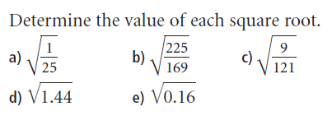

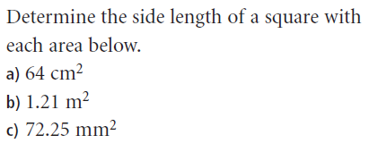

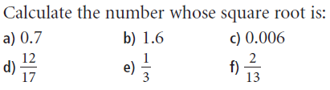

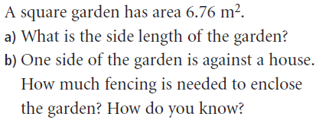

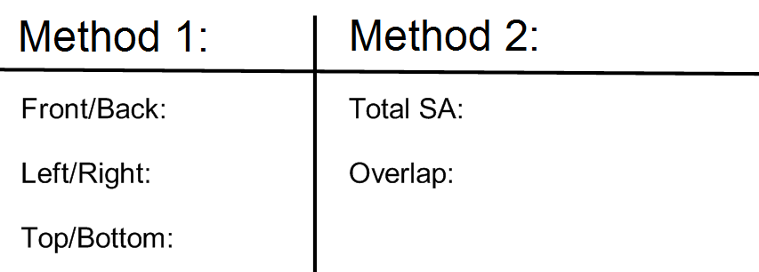
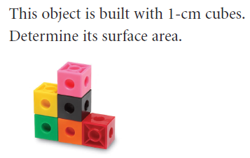

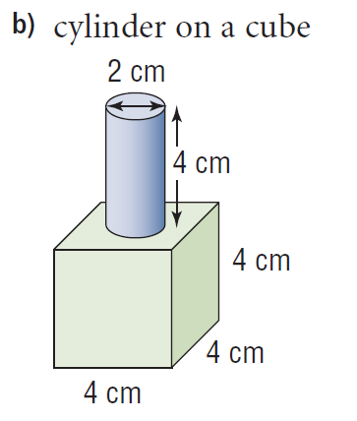
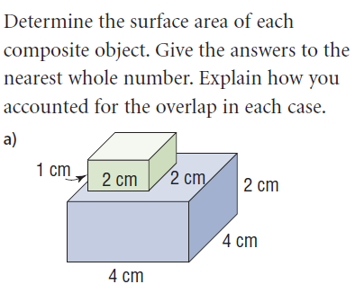

Show all steps; calculations. Show all steps; calculations.
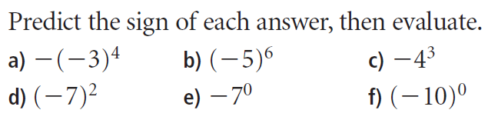
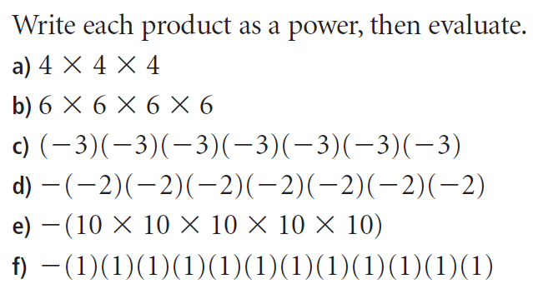
- 8)

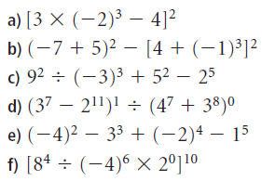
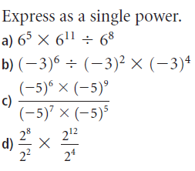
9) Show all steps; calculations. 10) Show all steps; calculations.

11) Show all steps; calculations
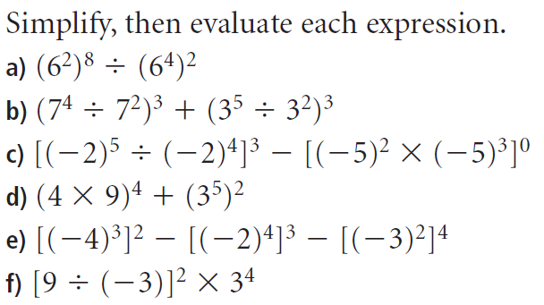

12) Label a number line from -4 to 2; write 3 integers between -4 and 2 (one must be a fraction).
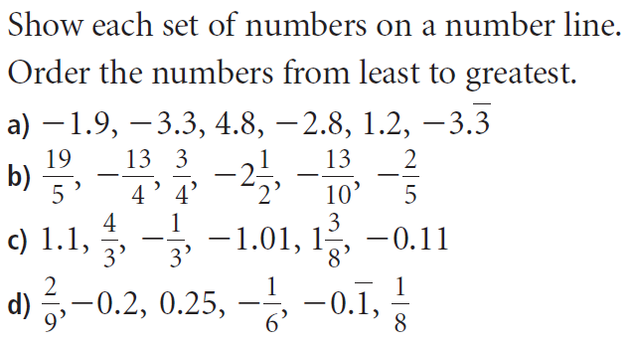
13)

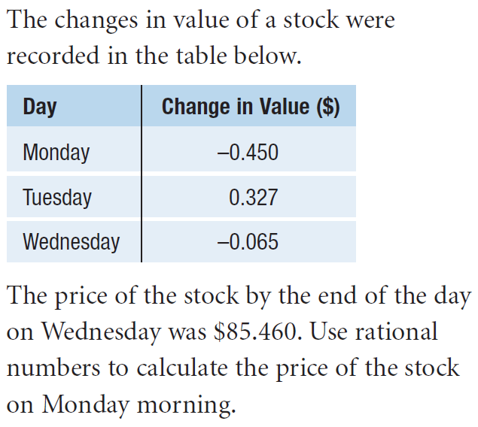
14)

