Term I Science Exam Review
Pages from Notebook:
Page 4 - The Cell Theory
Page 5 - Mitosis
Page 6 - Meiosis
Page 7 - Mitosis vs Meiosis
Page 8 - Asexual Reproduction and Types
Page 9 - Sexual Reproduction in Plants
Page 10 - DNA
Page 11 - Fertilization
Page 12 - Fetal Development

Terms/Vocabulary:
- Angiosperms/Gymnosperms
- Importance of Cell Division
- Healing and Tissue Repair
- Growth
- Reproduction
- Cell Cycle/ Mitosis
- Prophase
- Metaphase
- Anaphase
- Telophase
- Interphase
  - Asexual Reproduction
    - Binary Fission
    - Budding
    - Fragmentation
    - Vegetative reproduction
- Sexual Reproduction
- Internal Fertilization
- External Fertilization
- Zygote
- Gestational Period
- DNA (Deoxyribonucleic Acid)
- Sugar
- Phosphates
- Adenine
- Thymine
- Cytosine
- Guanine
- Gene
- Variation
- DNA Replication
- Mutations
- Carcinogens
- Chemicals
- Radiation
- Viruses
- Meiosis
- Diploid/Haploid Cells
- Sex Cells/ Reproductive Cells

Questions:

- What are the three components of cell theory?

- How has cell theory been used?

- What is the purpose of mitosis?

- Complete the table below:

Order of Stage | Picture | Description of Stage

- What is the difference between Mitosis and Meiosis?

- What does crossing over refer to?

- What is asexual reproduction? Explain what the four common types are.

- How can pollination occur in plants?

- What is the purpose of DNA?

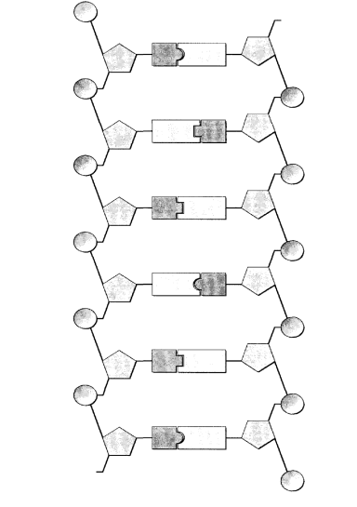
- Label the following DNA strand:

- What are mutations? Give an example.

- What is the difference between internal and external fertilization? Explain.

- What type of fetal development is occurring during the First, Second and Third trimesters?

