Term II Math Exam Review
Pages from Notebook:
Page 22 - Linear Relations
Page 23 - Parts of the Graph
Page 24 - Slope/Intercept Form and Finding Solutions
Page 25 - Horizontal and Vertical Linear Equations
Page 26 - Finding Slope
Page 27 - Graphing Linear Equations with a Table of Values
Page 28 - Criteria for Identifying Graphs
Page 29 - Graphing Using the Y-Intercept and Slope
Page 30 - Intro to Polynomials
Page 31 - Combining Like Terms
Page 32 - Adding and Subtracting Polynomials
Page 33 - Multiplying Monomials and Polynomials
Page 34 - Dividing Monomials
Page 35 - Solving Equations
Page 36 - Linear Inequalities
Page 37 - Graphing Inequalities on a Number Line
Page 38 - Solving Inequalities
Page 39 - Solving Inequalities (Negative #s)
﻿

Questions:
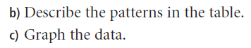
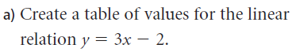

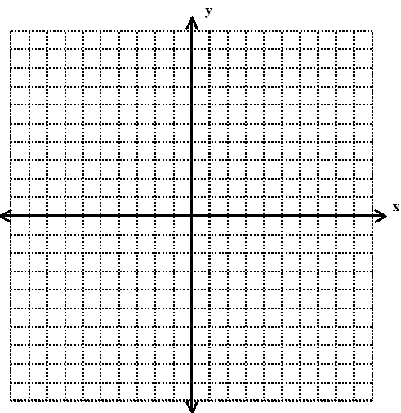
y | x

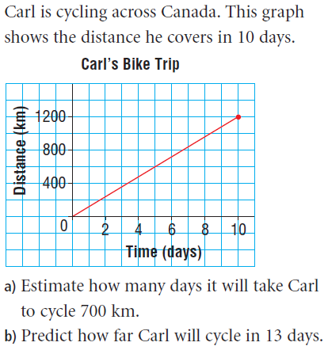
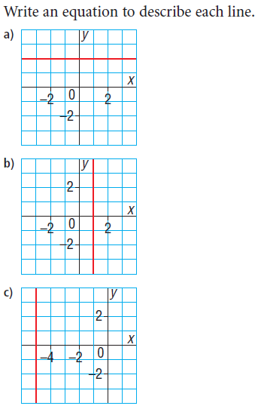
2) 3)

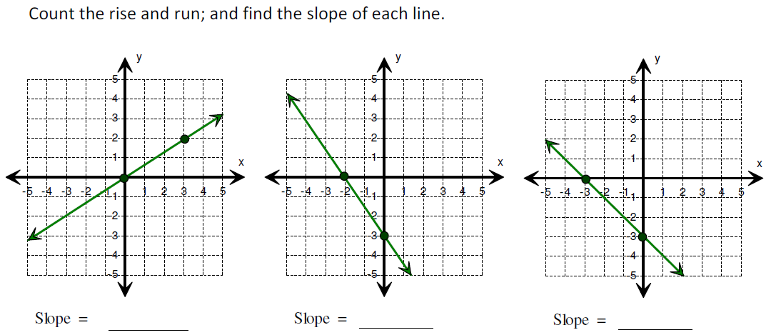
4)

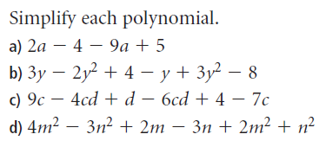
5)

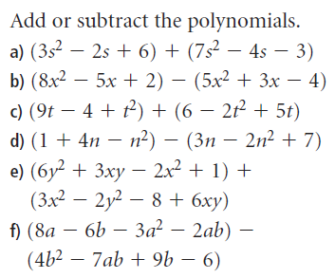
6)

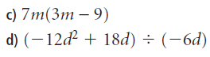
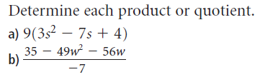
7)

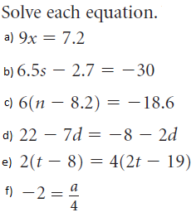
8)

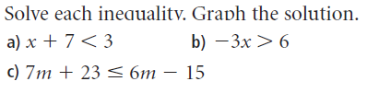
9)

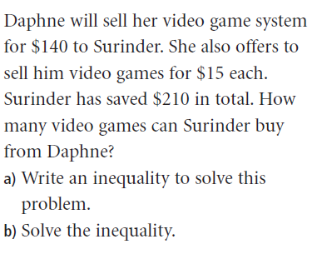
10)

