Term II Science Exam Review
Pages from Notebook:
Page 13 - The Particle Theory of Matter
Page 14 - The Changing States of Matter
Page 15 - Physical/Chemical Properties and Changes in Matter
Page 16 - Density
Page 17 - Atomic Theory
Page 18 - Atomic Structure
Page 19 - Periodic Table of Elements
Page 20 - Bohr Diagrams
Page 21 - Chemical Compounds and Formulas

Terms/Vocabulary:
- Matter
- Density of Matter
- States of Matter (Freezing/Melting, Evaporation/Condensation, Sublimation/Desublimation)
- Physical Properties
- Chemical Properties
- Physical Change
- Chemical Change
- 4 Parts of the Particle Theory of Matter
- Chemical Symbols
- Chemical Names
- Chemical Formulas
- Ball and Hook Diagrams
- Combining Capacity/Charges/# of Hooks
- Counting Atoms
- Subatomic Particles
- Protons
- Electrons
- Neutrons
- Counting Subatomic Particles
- Bohr Diagrams
- Periodic Table

Questions:

- What are the four principles of the Particle Theory of Matter?

- Describe the changing states in matter between:
- Liquids and solids
- Solids and Gases
- Gases and Liquids

- How can we determine whether a physical or chemical change has occurred in a substance?

- Give 2 examples of a physical change and 2 examples of a chemical change.

- Draw a diagram to show the differences in density between gases, liquids and solids.

- What are the four parts of Dalton’s Atomic theory?

- Explain the structure of an atom (include the words protons, neutrons and electrons in your description).

- What is the difference between a chemical compound and a chemical formula?

- Complete the table below; reference your periodic table:

Element | Symbol | Protons | Neutrons | Electrons
Lead
 | Cu
 | Ca
 |  | 19
 |  |  |  | 47

- Draw the Bohr diagram for the elements below:
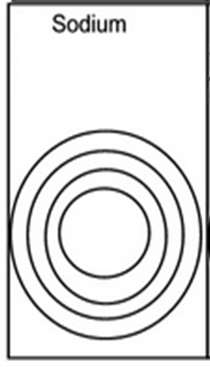
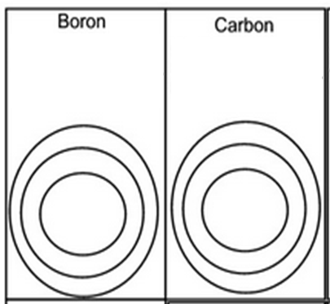
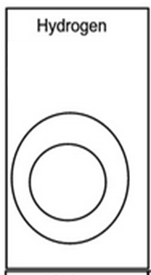

- For the following chemical formulas, give the proper name:

CO₂ __________________________________________
N₃S __________________________________________
P₂H₂ __________________________________________ BF₄ __________________________________________

- For the following chemical names, give the proper formula:

nitrogen dichloride _____________________________________
boron trioxide _________________________________________
nitrogen dioxide __________________________________________
phosphorus pentafluoride ______________________________________
sulfur dibromide __________________________________________

