Term III Math Exam Review
Pages from Notebook:
Page 40 - Units of Measurement
Page 41 - Rates and Ratios
Page 42 - Scale Factor
Page 43 - Similar Polygons
Page 44 - Similar Triangles and Applications
Page 45 - Lines of Symmetry
Page 46 - Tangents to a Circle
Page 47 - Chords in a Circle
Page 48 - Circle Angle Properties
Page 49 - Types of Probability
Page 50 - Sampling and Bias﻿

Questions:

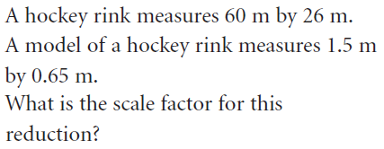
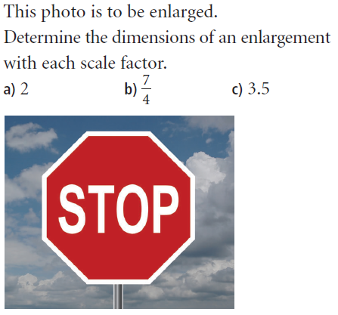
1) 2)

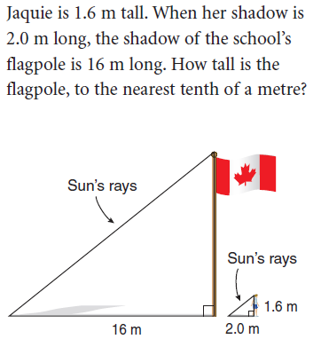
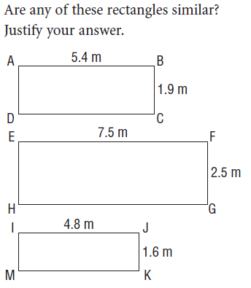
3) 4)

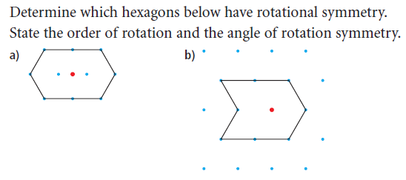
5)

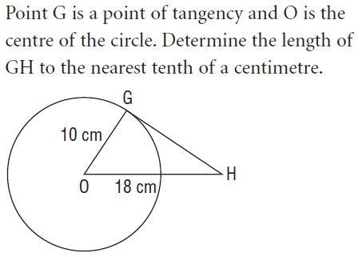
6)

7) a) Draw and label the circle to illustrate an inscribed angle and a central angle subtended by (coming from) the same arc.

What is the relationship between the angles?

b) Draw and label the circle to illustrate THREE inscribed angles subtended by (coming from) the same arc.

What is the relationship between the angles?

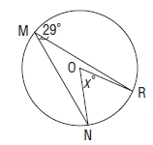
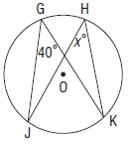
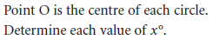
8)

9) Give an example of theoretical, experimental and subjective probability.

10) Does the survey question “Do you prefer to play soccer or basketball?” contain bias? If so, rewrite the question to avoid bias.

