Term III Science Exam Review
Pages from Notebook:
Page 22 - Planet Data Sheet
Page 23 - The Big Bang Theory
Page 24 - Aboriginal vs Western Knowledge of the Solar System
Page 25 - Types of Galaxies
Page 26 - Static Electricity
Circuit Scribe Labs #1-6

Terms/Vocabulary:
- Expanding Universe
- Holistic scientific view
- Western scientific view
- Big Bang Theory
- Galaxies
- Spiral
- Elliptical
- Irregular
- Stars
- Dwarf stars
- Black Hole
- Electric Charges
- Negative
- Positive
- Neutral
- Static Electricity
- Electric Charge
- Law of Electric Charges
- Insulators
- Examples of good insulators
- Conductors
- Examples of good conductors
- Electric Current
- Electric Circuit
- Parts of a Circuit
- Open circuit “Off”
- Closed circuit “On”
- Circuit Diagrams
- Amps (A)
- Resistor
- Resistance
- Ohms (Ω)

Questions:
1) What evidence is there to support the Big Bang theory?
2) Describe the three common types of galaxies (include a pictorial representation of each).
3) What is static electricity?
4) What are the three laws of static charges?
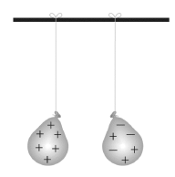
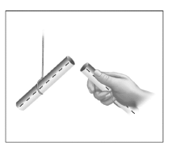
5) Analyze the situations depicted below; identify whether the objects will attract or repel:
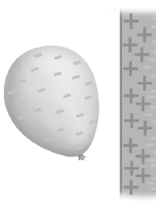
a) b) c)

_______________________ ________________________ _____________________
6) Give two examples of good conductors and two examples of good insulators.

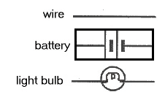
7) Using the following symbols, draw a diagram of a simple circuit (be sure to include directional arrows for the current and the positive and negative sides of the battery):

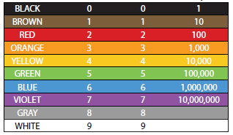
8) Using the resistance chart below, complete the following:

a) If a resistor has a value of 2000 ohms what would the color code on the resistor be?

b) If a resistor has a color code of brown, black, brown, what is the resistor value?

